MSE 111: Properties of Electronic Materials

Instructor: Prof. Junqiao Wu
wuj@berkeley.edu, http://www.mse.berkeley.edu/~jwu
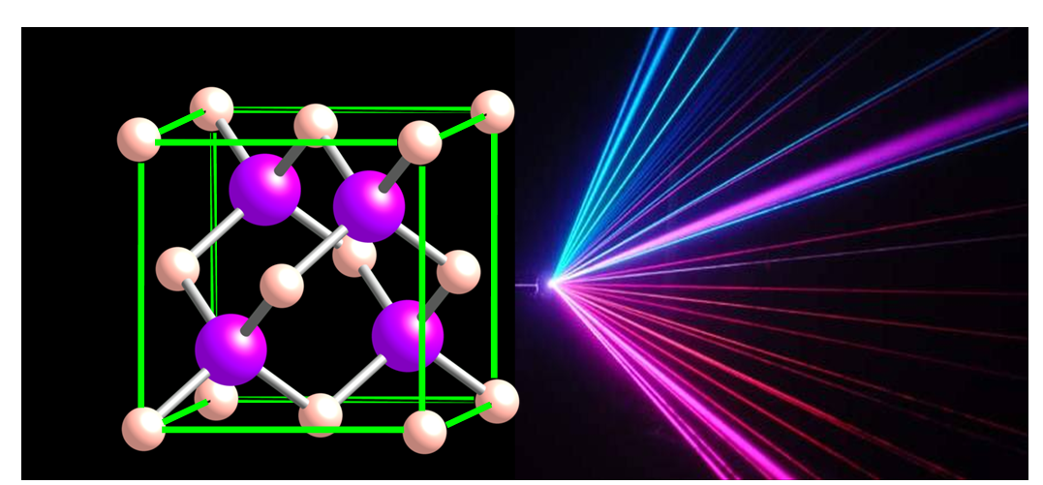
- the zincblende structure of common semiconductors, and emission of semiconductor lasers.

ONLINE RESOURCES
Course website: http://bcourses.berkeley.edu
Only enrolled students may access this site. Login with your CalNet ID, then select the MSE111. If you don’t have access to bcourses, please come see the instructor for electronic copy of course materials.

CATALOG DESCRIPTION
Introduction to the physical principles underlying the electronic properties of solids from macroscopic to nano dimensions. General solid state physics will be taught in the context of technological applications, including the structure of solids, behavior of electrons and atomic vibration in periodic lattice, and interaction of light with solids. Emphasis will be on semiconductors and the materials physics of electronic and optoelectronic devices.

COURSE PREREQUISITES
E45, Physics 7A-7B-7C or consent of instructor

PREREQUISITE KNOWLEDGE AND/OR SKILLS TEXTBOOK(S) AND/OR OTHER REQUIRED MATERIAL
Knowledge of introductory physics (e.g., atoms, electromagnetism, wave mechanics) and mathematics (e.g., calculus, differential equations, vectors, Fourier transform, complex numbers) is essential for this course. Required text: S. O. Kasap, Principles of Electronic Materials and Devices (McGraw Hill, 2002, or any other version)

COURSE OBJECTIVES
Students will gain a fundamental understanding of the following topics: i) electrical conduction (transport) in solids based on quantum mechanics and modern band theory, ii) lattice vibration and thermal conduction (transport) in solids, iii) major properties of bulk and nanostructured semiconductors, iv) effects of dopant impurities and defects in semiconductors, and v) the principles of light-solid interactions.

DESIRED COURSE OUTCOMES
Students who have successfully completed this course will have gained an understanding of:
- the structure of ideal crystalline solids and their defects
- the basics of electrical and thermal conduction in solids
- the major kinds of chemical bonds
- the behavior of electron as a particle and as a wave
- the basic free electron theory of metals
- the basic energy band theory of solids
- basic semiconductor materials properties
- free charge carrier distribution in intrinsic and extrinsic semiconductors
- physics of the p-n junction and related solar cells and light emitting diodes
- principles of light-solid interactions including light absorption and emission
The students will be able to use mathematical and conceptual approaches to applying this knowledge in solving a wide range of problems originating in semiconductor research and development and industrial technologies.

TOPICS COVERED
Introduction to Solid State Physics, Crystal Bonding, Basic Quantum Mechanics, Electrical and Thermal Conduction, Energy Band Structure of Solids, Intrinsic and Extrinsic Semiconductors, Carrier Transport and Recombination in Semiconductors, Properties of Semiconductor Nanostructures, Semiconductor Junctions, Solar Cells, LEDs, Defects in Semiconductors, Light Propagation, Absorption, and Emission in Solids.

CLASS/LABORATORY SCHEDULE
Lectures: Mon, Wed, 3:30-5:00pm 348 Hearst Mining Building
Discussion: TBD
Office hours: Tue 5-6:00PM, 322 Hearst Mining Building, or by email appointment

CONTRIBUTION OF THE COURSE TO MEETING THE PROFESSIONAL COMPONENT
The course provides a thorough fundamental understanding of properties of the solid state with emphasis on semiconductors. Many students from different departments who took the course in the past went on to positions in the semiconductor industry, and reported back that the course had provided them with a good background for their work. This course teaches the scientific and technological knowledge of solid materials (semiconductors, insulators, metals, etc.) that are important for the high-tech industry.

RELATIONSHIP OF THE COURSE TO UNDERGRADUATE DEGREE PROGRAM OBJECTIVES
This course is a core course in our electronic materials emphasis of the MSE undergraduate education. The science, technology, processing and making of devices of electronic materials are an integral part of any modern MSE undergraduate curriculum.

ASSESSMENT OF STUDENT PROGRESS TOWARD COURSE OBJECTIVES
Students prepare 13 sets of homework, which will be due in a week and will be graded based on completion rather than correctness. Solution to each homework will be thoroughly discussed in the discussion hour. There are one midterm exam and one final exam, both closed-book but an equation sheet will be provided.

PERSON(S) WHO PREPARED THIS DESCRIPTION
Prof. Junqiao Wu

COURSE PROGRAM (see syllabus for details):
1. Elementary materials science
2. Electrical and thermal conduction
3. Elementary quantum mechanics
4. Modern theory of solids
5. Semiconductors
6. Semiconductor devices
7. Optical properties (if time allows)

GRADING:
13 Homeworks (graded based on completion rather than correctness): 20%
1 Midterm (closed book, eqns will be provided): 30%
Final Exam (closed book, eqns will be provided): 50%

